Euel Domingo, Adam Preston, Marcus Robinson-Bailey, Kester Gideon

CO600  University of Kent

Website Design and Documentation

Table of Contents

Introduction 2

Purpose 2

Layout and Formatting 2

Theme 2

Layout 3

Technology 3

Functionality 4

Features 5

Adapting to the size of the browser window 5

Modal 5

Meeting the requirements 5

User interface for the Terms and Conditions Analyser 5

Plain, easy to read formatting 5

Easy navigation throughout sections of the website 5

References 5

# Introduction

The purpose of this document is to provide information regarding on the one-page website which is the user interface for the Terms and Conditions Analyser. It will talk about the design, functionality and how it meets the purpose of the website.

# Purpose

The goal of the website is to allow users to review the terms and conditions they want to analyse. The website will have a text area where users can paste a copy of the terms and conditions to the text area. After adding the text to the text area, there will be a button called ‘Analyse’ where the website will send the document to a server for analysis. Finally, when the server successfully analyses the document, it will return a list of risky statements and the website will display the list to the user.

# Layout and Formatting

## Theme

The design of the webpage will be created from a template ‘Miniport’ taken from <https://html5up.net/>. The template provides the fundamental design and functionality needed for the website. The only changes needed will be the content such as the headers, text and images.

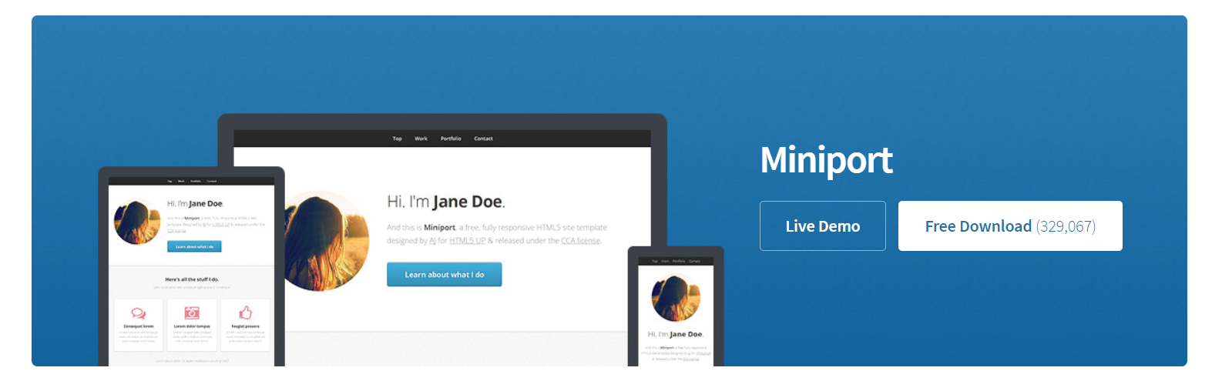

Figure 1. Miniport Template from <https://html5up.net/>

The colours that will be used for the website are:

* White for the background
* Shades of Light and Dark Grey which will be used mainly for background and text.



* Blue mainly for the buttons.



## Layout

The navigation will always stay visible on top of the page.

Navigation

Interface

* Text area
* Analyse Button
* Clear Button

System Highlights

Heading

Logo

Figure 2. Website Layout

# Technology

* HTML
* CSS
* JavaScript
* Ajax
* jQuery

The Ajax developed in the website handles the communication between the client (i.e. website) side and the server (i.e. Classification Algorithm API) side. The main goal of this technology is to establish connection with the server, send the document in the correct format so that the Classification Algorithm API running on the server can process it, and reads the data returned by the server. The technology is capable of catching errors if a user inputs incorrect data.

# Functionality

Users will need to copy the Terms and Conditions and paste it to the text area. A copy means selecting or highlighting the terms and conditions, and triggering ‘Copy’ (i.e. pressing Ctrl+C).

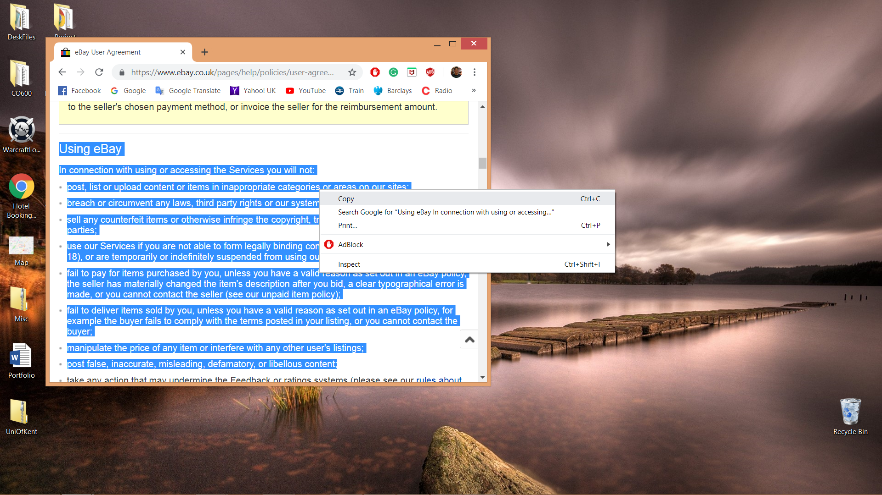

Figure 3. Copying text from a website.

When the user has a copy of the document, they will need to paste it onto the text area (i.e. clicking the text area and then pressing Ctrl+V).

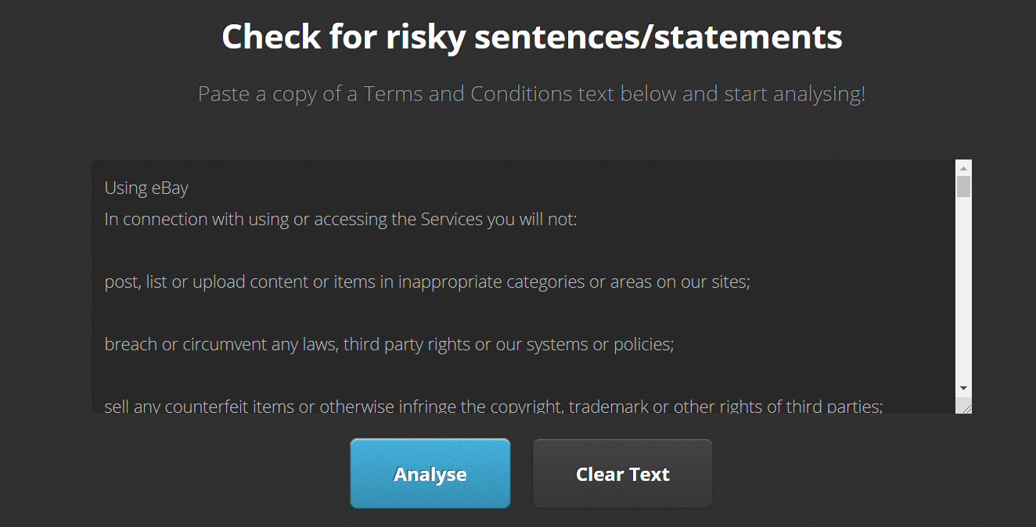

Figure 4. Pasting text onto the text area.

After the user has pasted the terms and conditions onto the text area, they should press ‘Analyse’ button so the website can send the copy to a server which is running the system that will analyse the document. After the document has been analysed, it will display to the user a list of risky statements found in the document.

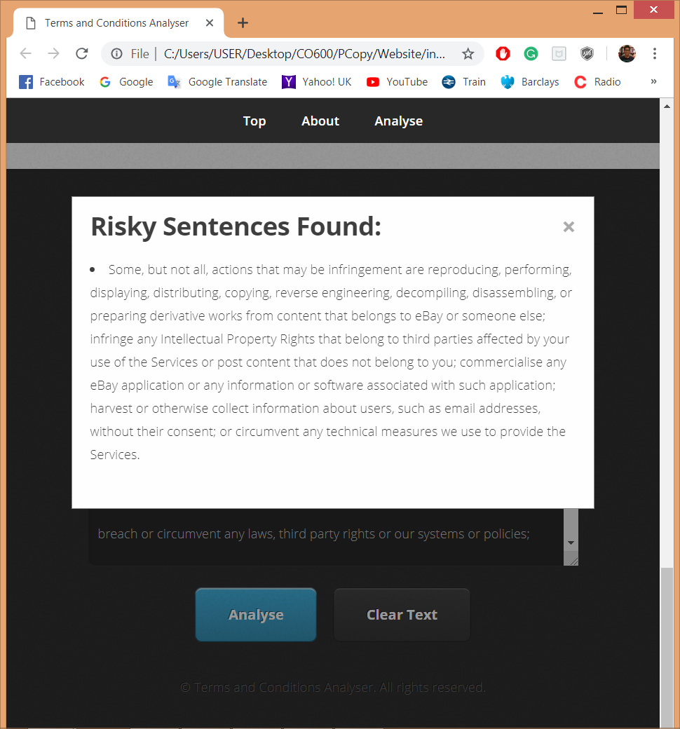

Figure 4. A list of risky statements shown to the user.

# Features

## Adapting to the size of the browser window

The CSS @media feature is setup to detect the size of the browser window and adapts the whole content to maintain high user readability and quality. The three main sizes that this feature detects are a desktop version, tablet version and a mobile version. In addition, it can detect the window’s orientation. This feature will allow users to be able to use the website from different devices.

## Modal

This is a feature within the website where its main goal is to show the list of risky statements to the user (See Figure 4 from previous page). This appears when the ‘Analyse’ button is triggered in the website. The modal is positioned over the website and it allows user to scroll through the content or the list if it is bigger than the viewport of the user. The website will temporarily have a fade effect while the modal is up. Whenever the user clicks the cross button or outside the content of the modal, the modal disappears.

# Meeting the requirements

## User interface for the Terms and Conditions Analyser

The website meets the user interface requirement of the project. It provides an input area, which is the text area, and a button, which triggers a confirmation to the system that the text document in the text area is ready to be processed. Finally, when the system has finished analysing the document, it returns a list of risky statements for users to review.

## Plain, easy to read formatting

The colours used are plain and do not contrast such as that the text does not contrast with the background. The light grey background of the website makes the text stand out for high readability. The font style used

## Easy navigation throughout sections of the website

The navigation bar is always at the top of the page. Whenever a user changes sections within the website, the navigation bar will always follow the user for easy navigation. Both the first section (i.e. Header/Top section) and the second section (i.e. About section) have a button that directs user to the Main section, which is the user interface.

# References

The logo used in the website is taken from the cover of an eBook in Amazon ‘Terms & Conditions: Must Be Met’ by Ashish Jindal. The link to the eBook: <https://www.amazon.com/Terms-Conditions-Must-Be-Met-ebook/dp/B01NACF2YS>